**Regression Decision Tree**

In Classification decision Tree, we formed best optimum tree and after which we were deciding that which item should go into which category.

In Regression Decision Tree we are going to split the regression points into categories,

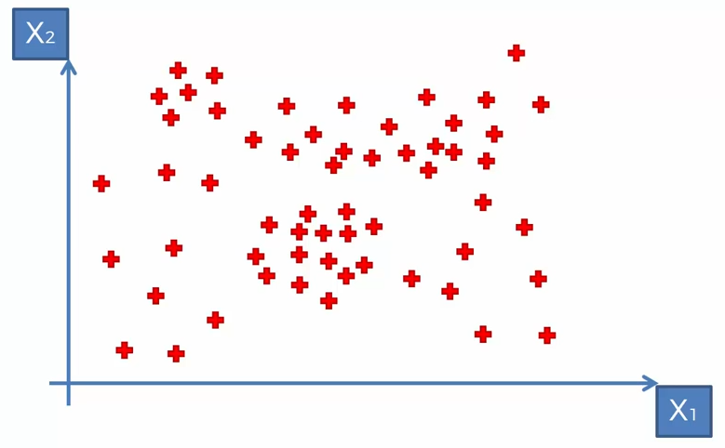

Let’s Imagine, we have above points and we are going to split these points based on some categories,

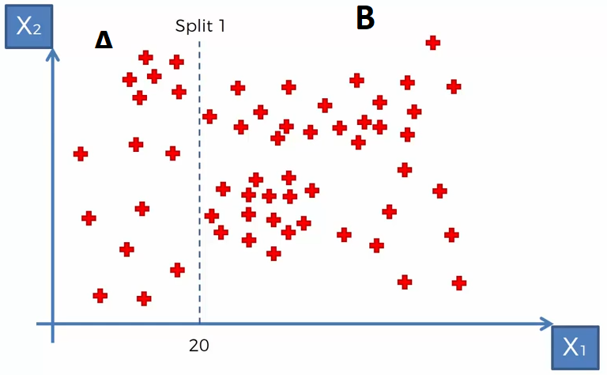

We have divided the points into 2 categories and mediator condition is, points less than 20 and more than 20. **A** category is less than 20 and B category is more than **B**.

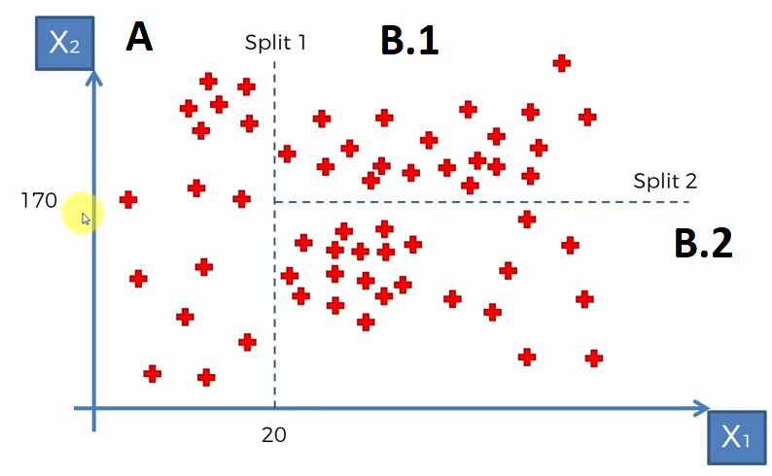

Again, we are Dividing the B part into 2 parts as B.1 and B.2 by Area less than 170 is B.2 and Area more than 170 is B.1

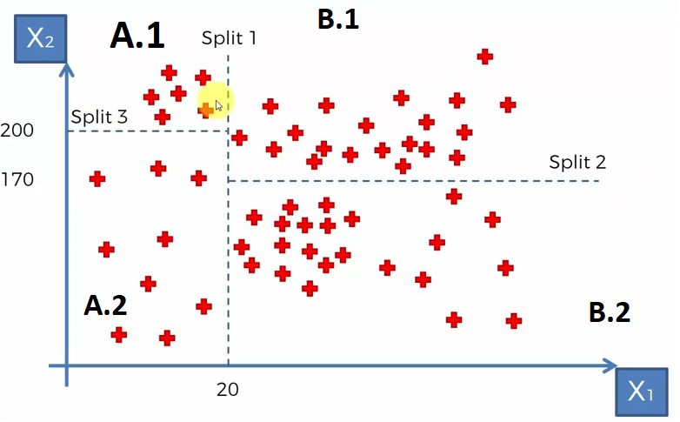

Again, we are Dividing the A part into 2 parts as A.1 and A.2 by Area less than 200 is A.2 and Area more than 200 is A.1

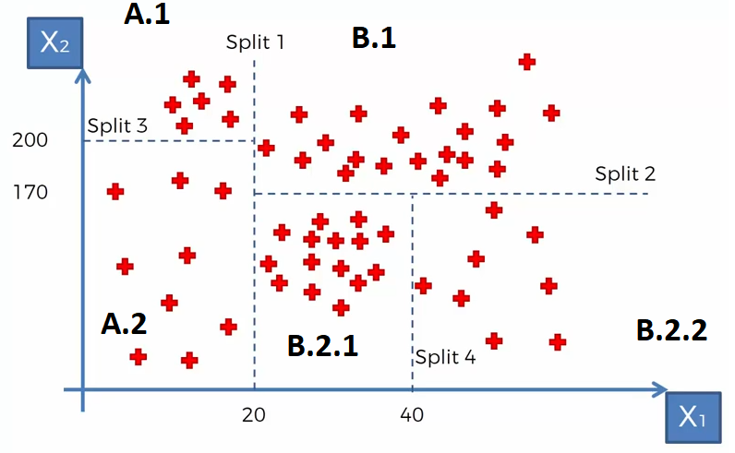

Again, we are Dividing the B.2 part into 2 parts as B.2.1 and B.2.2 by Area less than 40 is B.2.1 and Area more than 40 is B.2.2

So, we are keep on dividing the Points into part till they comes into specific categories.

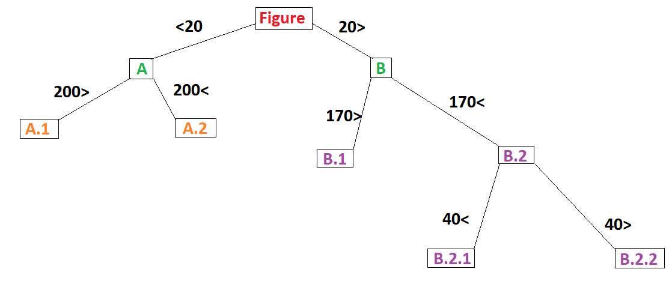

If we form a tree depending on categories then, Tree will look like above figure.

#Now, we can take the average of all blocks,

Average of A.1, Average of A.2, Average of B.1, Average of B.2.1 , Average of B.2.2 Then, Based on the average we are going to find the output of input.